Exercise week 3:
Sustained proliferative signaling I – Receptor tyrosine kinases
1) For memorization:
a) What characterizes the growth of "transformed" cells (by definition)?
b) What are SH domains, and what are their functions?
c) What do geneticists mean if they say that EGFR and Son-of-Sevenless (Sos) are epistatic?

2) Exam-style MCQ:
Which one of the following statements about oncogenic mutations is false:
- CDK4,6 activity induces cell division by phosphorylating cyclin D
- RTKs can become oncogenic by mutations that delete the extracellular domain
- EGFR frequently becomes oncogenic by means of gene amplification
- The mutations that make KRAS oncogenic inhibit its GTPase activity, rather than stimulating it
- G12C mutant KRAS can be targeted by drugs that covalently bind its inactive form

3) Mechanism-based explanations
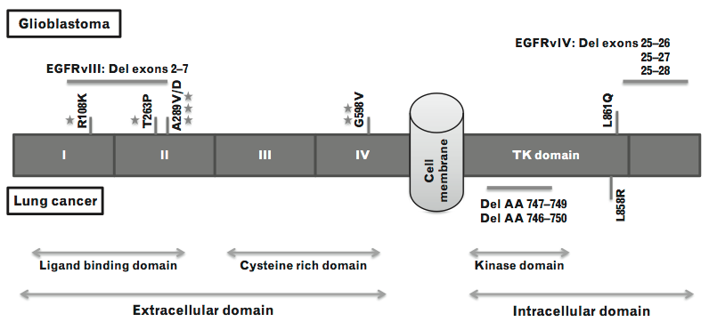
40% of GBM cases show mutations in the EGFR gene. Particularly common (26%) is a truncation of the extracellular domain by deletion of exons 2 to 7 (EGFR vIII, Fig. 1).
FIGURE 1. Mutations in the epidermal growth factor receptor gene associated with glioblastoma and non-small cell lung cancers (NSCLC). Missense mutations reported from glioblastoma are clustered in the extracellular domain. The most common mutations are annotated and indicated by marks above the gene bar for glioblastoma. In contrast, mutations reported from lung cancer are located in the kinase domain, indicated below the gene bar. (Hegi et al. 2012, Curr Opin Neurol 25:774-9)
a) How does this truncation lead to EGFR hyperactivation?
b) Oncogenic KRAS mutations are extremely rare in GBM. They also only very rarely co-occur with EGFR mutations NSCLCs (<5% of all all cases examined). If GBMs become resistant to all available EGFR inhibitors, would it make sense to consider treating patients with the recently approved KRAS inhibitor Sotorasib? Why or why not?
c) Why are only so few mutations in Ras oncogenic, compared to the many different oncogenic point mutations found in EGFR?
4) Data interpretation: Therapeutic targeting of KRAS in lung cancer
In lung adenocarcinoma (LuAd), activating mutations in either KRAS or EGFR are mutually exclusive. EGFR inhibitors are clinically approved for non-small cell lung carcinoma (NSCLC). However, only 70% of patients respond, and these do so only transiently (<12 months). In a search for strategies to overcome drug resistance, researchers have investigated the effect of inhibiting MEK, a kinase downstream of KRAS that mediates activation of the so-called extracellular signal-regulated kinase ERK1:
RAS/Raf MEK ERK1 cell proliferation & growth
a) In a subset of metastatic NSCLC patients carrying the oncogenic Val600>Glu mutation in the Raf family member B-RAF, a combination treatment with the V600E mutant-specific B-RAF inhibitor (BRAFi) dabrafenib plus the MEK inhibitor (MEKi) trametinib has been approved by the FDA in 2018. Given this synergism with BRAFi, should one also consider combine MEKi with second generation EGFR/ERBB family inhibitors? Why or why not?
FIGURE 2. Analysis of tumors in KM mice that were engineered to express KrasG12D and elevated levels of another oncogene, c-Myc, specifically in lung epithelial cells. A) Multiple papillary lung adenocarcinoma in situ 6 weeks post-induction of oncogenic KrasG12D and c-Myc alleles, stained (brown) for phosphorylated extracellular signal-regulated kinase (p-ERK). B) Immunohistochemical staining of p-ERK in liver metastases 6 months post-induction. Quantification of the fraction of stained cells per metastasis is shown below. C) Histological quantification of tumor burden in lungs of KM mice treated daily with neratinib or erlotinib for 4 weeks, commencing 2 weeks after induction of oncogenic KrasG12D and c-Myc alleles. D) Overall survival of tumor-bearing KM mice treated daily for 1 week (orange bar) with neratinib, or with the MEK inhibitor trametinib, or both, then followed without further intervention. Treatment was commenced at 5 weeks; the number of mice analyzed per group is indicated in brackets). Log-rank hazard ratios (HR ± 95% confidence interval) and P values are shown for the indicated comparisons (dashed lines). E) Lysates of individual tumors from mice treated with neratinib and/or trametinib for 3 days, analysed by Western blotting using antibodies against the indicated proteins (total, t) or specific phosphorylated tyrosine (Y) or serine (S) residues that mark their activation.

b) The ERBB inhibitor neratinib was administered with or without trametinib to engineered mice that express oncogenic mutant Kras^{G12D} specifically in lung epithelial cells. c-Myc, a transcription factor important for most cancer types, was overexpressed as a transgene in the same cells, allowing Kras^{G12D} to rapidly induce multiple tumors (within ≤6 weeks). Less than 5% of those lesions (Fig. 2A, magnified area), and only a fraction of cancerous cells in liver metastases of older mice (6 months) stained positive for p-ERK1 (Fig. 2B).
- Why was this unexpected (back in 2018) that Kras^{G12D} activated ERK1 in only 5% of the tumor cells?
- What additional mutations or changes in gene expression would you consider as candidates for increasing p-Erk levels in this subset (5%) of cells?

c) Treatment of KRAS mutant lung cancer patients with the EGFR-specific inhibitors Erlotinib or Gefitinib has no benefit. Here, Erlotinib treatment similarly failed to inhibit tumor growth in KM tumor-bearing mice; however, Neratinib which blocks multiple ERBB family members largely suppressed tumors during the time window examined (Fig. 2C). To distinguish how Neratinib achieved this, your lab project supervisor asked you to treat cultured Kras^{G12D} mutant (KM) cells with Neratinib or with the ERBB ligand neuregulin. How would this experiment allow you to distinguish if Neratinib slows tumor growth in vivo by blocking an autocrine or a paracrine growth factor signal?

d) The Kaplan-Meier plot in panel D reveals no benefit for Neratinib treatment alone. Tumors that had been treated for 3 days with the indicated drugs were lysed and analyzed by Western blot in panel E. How do these blots confirm whether Neratinib and Trametinib each reached their target(s)?
Do these Western blot data support the model that ERBB family members are the main RTKs driving MEK/Erk signaling in these tumors? Why or why not?

